FADHIL PRAWIRA

21060120140057

UAS PBO

No1

|  |
| --- |
| interface Harga_21060120140057 {  double *biayaperKg* = 0; } public class Paket_no1_21060120140057 implements Harga_21060120140057{  public String nmPengirim;  public String tujuanPaket;  public int beratPaket;  public double biayaperKg;  public double bayar;  public String getNamaPengirim() {  return nmPengirim;  }   public String setNamaPengirim(String temp){  nmPengirim=temp;  return nmPengirim;  }   public String setTujuanPaket() {  return tujuanPaket;  }   public int beratPaket() {  return beratPaket;  }   public void biaya() {  if(tujuanPaket.equalsIgnoreCase("Semarang")){  biayaperKg=10000;  }  else if(tujuanPaket.equalsIgnoreCase("Jawa Tengah Luar Semarang")){  biayaperKg=20000;  }  else if (tujuanPaket.equalsIgnoreCase("Luar Jateng P. Jawa")){  biayaperKg=30000;  }  else { //Luar jawa  biayaperKg=50000;  }  bayar = beratPaket*biayaperKg;  System.*out*.println(nmPengirim+", untuk pengiriman ke " + tujuanPaket + " seberat " + beratPaket + "kg, Anda perlu membayar Rp" + bayar);  }   public static void main(String[] args) {  Paket_no1_21060120140057 barang1 = new Paket_no1_21060120140057();   barang1.tujuanPaket = "Semarang";  barang1.beratPaket = 2;  barang1.nmPengirim = "Fadhil";   barang1.biaya();  } } |

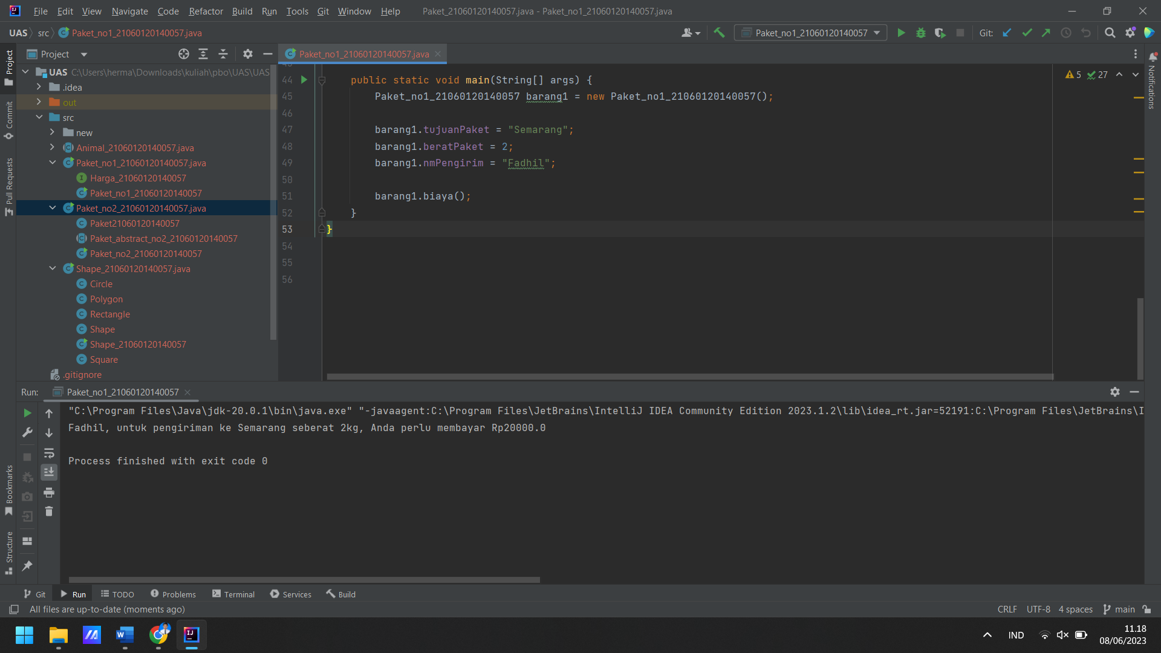

No2

|  |
| --- |
| abstract class Paket_abstract_no2_21060120140057 implements Harga_21060120140057 {  protected String nmPengirim;  protected String tujuanPaket;  protected int beratPaket;  protected int hargaPerKg;  protected double biaya;   public String getNmPengirim() {  return nmPengirim;  }   public void setNmPengirim(String temp) {  nmPengirim = temp;  }   public String getTujuanPaket() {  return tujuanPaket;  }   public void setTujuanPaket(String temp) {  tujuanPaket = temp;  }   public int getBeratPaket() {  return beratPaket;  }   public void setBeratPaket(int temp) {  beratPaket = temp;  }   public abstract double biayaPerKg();   public void biaya() {  biaya = beratPaket * hargaPerKg;  System.*out*.println(nmPengirim+", untuk pengiriman ke " + tujuanPaket + " seberat " + beratPaket + "kg, Anda perlu membayar Rp" + hargaPerKg);  } }  class Paket21060120140057 extends Paket_abstract_no2_21060120140057 {  public double biayaPerKg() {  if (tujuanPaket.equalsIgnoreCase("Semarang")) {  hargaPerKg = 10000;  return hargaPerKg;  } else if (tujuanPaket.equalsIgnoreCase("Jawa Tengah Luar Semarang")) {  hargaPerKg = 20000;  return hargaPerKg;  } else if (tujuanPaket.equalsIgnoreCase("Luar Jateng P.Jawa")) {  hargaPerKg = 20000;  return hargaPerKg;  } else if (tujuanPaket.equalsIgnoreCase("Luar Jawa")) {  hargaPerKg = 50000;  return hargaPerKg;  } else {  hargaPerKg = 50000; // Penambahan tanda = agar sesuai dengan sintaksis  return hargaPerKg;  }   } }  public class Paket_no2_21060120140057 {  public static void main(String[] args) {  Paket21060120140057 paket = new Paket21060120140057();  paket.nmPengirim = "Fadhil";  paket.tujuanPaket = "Semarang";  paket.beratPaket = 5;  paket.biaya();   } } |

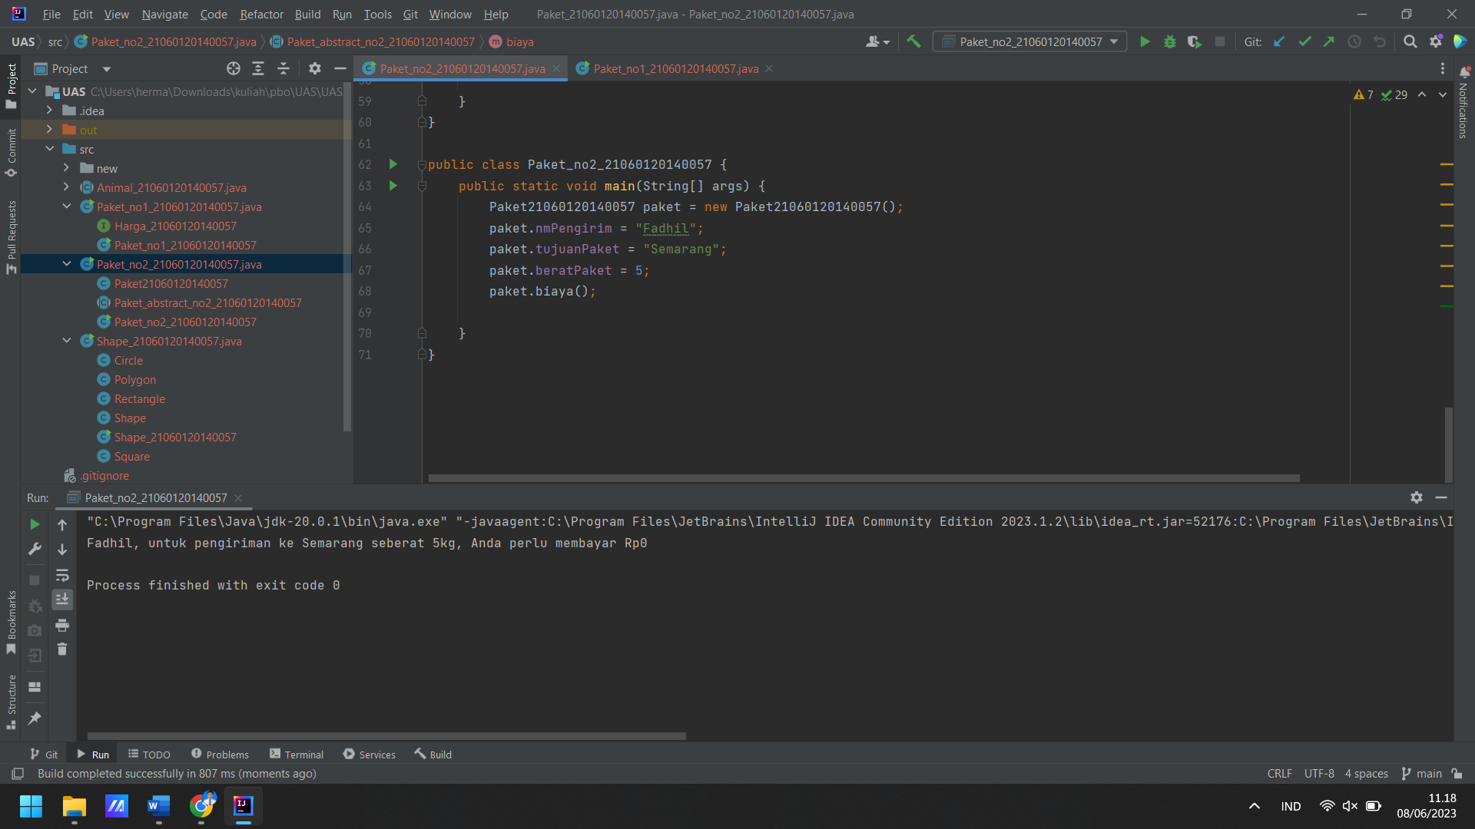

No3

|  |
| --- |
| import java.util.Scanner;  class Shape {  private int origin;   public void move() {  try (Scanner myObj = new Scanner(System.*in*)) {  System.*out*.println("Objek dipindahkan.");  }  }   public void display() {  try (Scanner myObj = new Scanner(System.*in*)) {  System.*out*.println("Objek ditampilkan.");  }  }   public void resize() {  try (Scanner myObj = new Scanner(System.*in*)) {  System.*out*.println("Objek diubah ukurannya.");  }  } }  class Rectangle extends Shape {  int corner; }  class Circle extends Shape {  private float radius; }  class Polygon extends Shape {  int point;   public void Display() {  try (Scanner myObj = new Scanner(System.*in*)) {  System.*out*.println("Objek ditampilkan.");  }  } }  class Square extends Rectangle {  }  class Shape_21060120140057 {  public static void main(String[] args) {   Shape object1 = new Shape();  object1.move();  object1.display();  object1.resize();   Rectangle object2 = new Rectangle();  object2.move();   Circle object3 = new Circle();  object3.move();   Polygon object4 = new Polygon();  object4.move();   Square object5 = new Square();  object5.move();  } } |

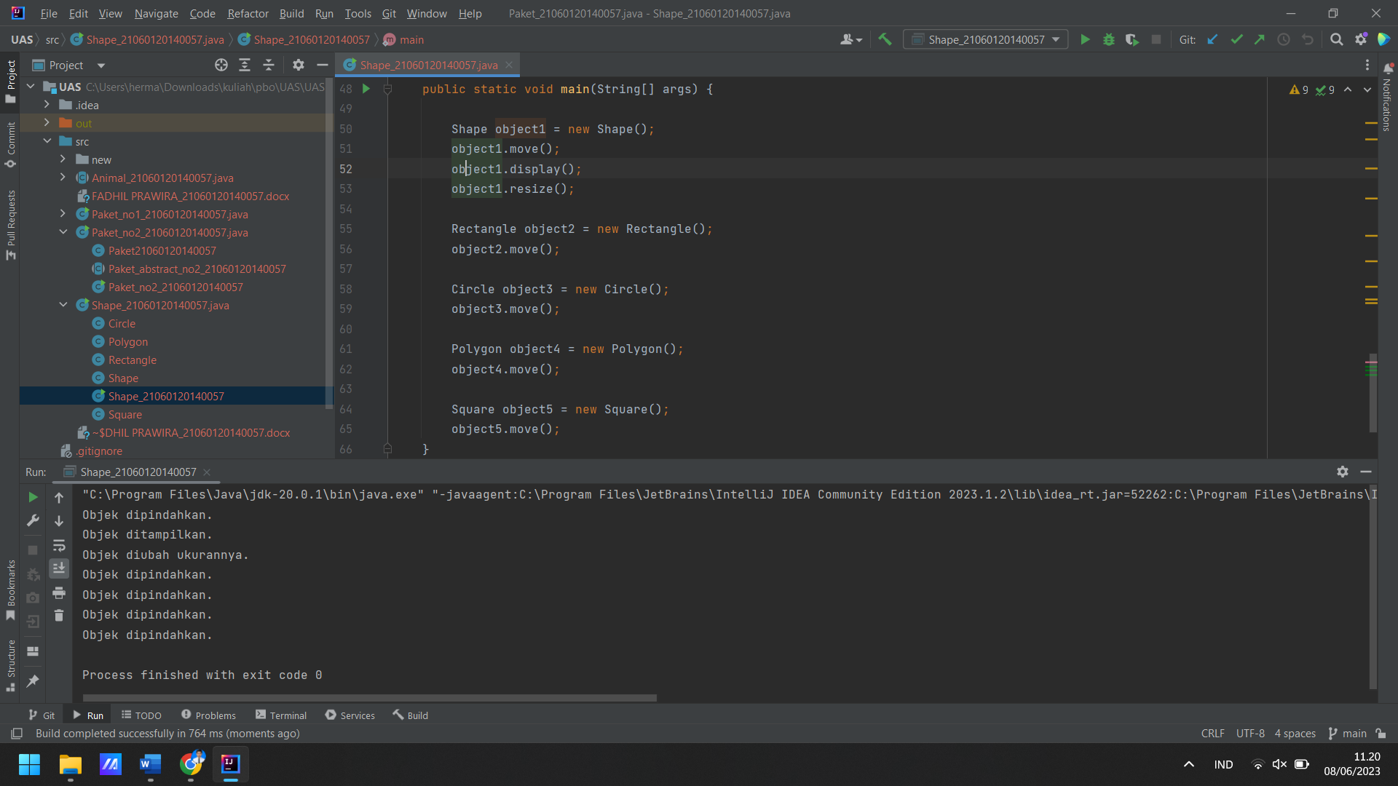

No4

|  |
| --- |
| public abstract class Animal_21060120140057 {  protected int legs;   protected Animal_21060120140057(int legs) {  this.legs = legs;  }   public abstract void eat();   public void walk() {  System.*out*.println("Binatang ini berjalan dengan " + legs + " kaki");  }   public static void main(String[] args) {  Fish d = new Fish();  Cat c = new Cat("Fluffy");  Animal_21060120140057 a = new Fish();  Animal_21060120140057 e = new Spider();  Pet p = new Cat();   d.eat();  d.walk();  c.eat();  c.walk();  a.eat();  a.walk();  e.eat();  e.walk();  p.play();  } }  class Spider extends Animal_21060120140057 {  public Spider() {  super(8);  }   @Override  public void eat() {  System.*out*.println("laba-laba ini memakan nyamuk");  } }  interface Pet {  void play(); }  class Cat extends Animal_21060120140057 implements Pet {  private String name;   public Cat(String name) {  super(4);  this.name = name;  }   public Cat() {  this("");  }   @Override  public void eat() {  System.*out*.println("The cat is eating.");  }   @Override  public void play() {  System.*out*.println("The cat is playing.");  }   public String getName() {  return name;  } }  class Fish extends Animal_21060120140057 {  public Fish() {  super(0);  }   @Override  public void eat() {  System.*out*.println("The fish is eating.");  }   @Override  public void walk() {  System.*out*.println("Fish cannot walk.");  } } |

